Which AFV host would you rather see when you are watching America’s Funniest Home Videos? (Bob Saget -1989 to 1997, Tom Bergeron – 2001 to 2015, or Alfonso Ribeiro – 2015 to present)
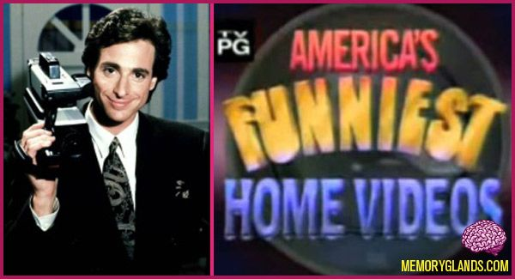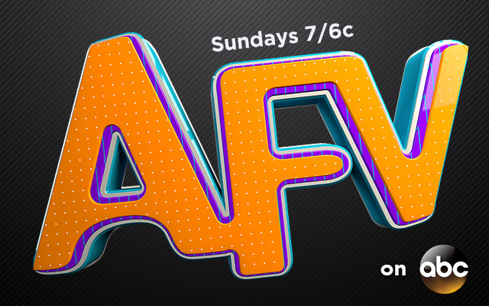
I would rather watch ___________ host Americas Funniest Home Videos. I feel this way because _________________________.

https://www.youtube.com/watch?v=-B9ORHj6qH4
https://www.youtube.com/watch?v=SHCpB5XiElk
http://abc.go.com/shows/americas-funniest-home-videos/episode-guide/season-27/21-episode-21

